Unit Exam:

  - How does Anti-differentiation relate to Differentiation?

A: Anti-differentiation is the opposite function of differentiation

  - Solve the following indefinite integral
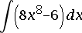

A: 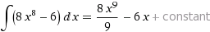

  - Evaluate the definite integral
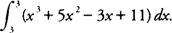
A: 0
  - Evaluate the definite integral
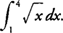

A: 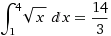
  - Solve the definite integral using U Substitution
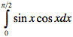

A: 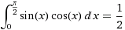
  - Find the anti-derivative of this function
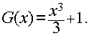

A: 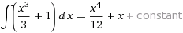

  - What is the area between the curve y= x² – 4 and the x-axis?
A: 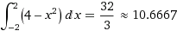
  - Integrate (2x)(cosx)dx using integration by parts.
A: 