Pretest

- What is the derivative at a point on a curve?

A: The derivative is the slope at that point on the curve.

- Derive the function f(x) = 2cosx

Answer: 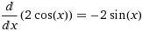

- Derive the function y = (2x – 1)³

Answer: 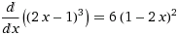

- Derive the function f(x) = 5x³ + 4x² + x + 17

Answer: 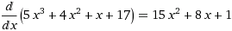

- Derive the function y= sinx + 7cosx + (14x-4+x)⁴

Answer:

